Funeral Planning Guide

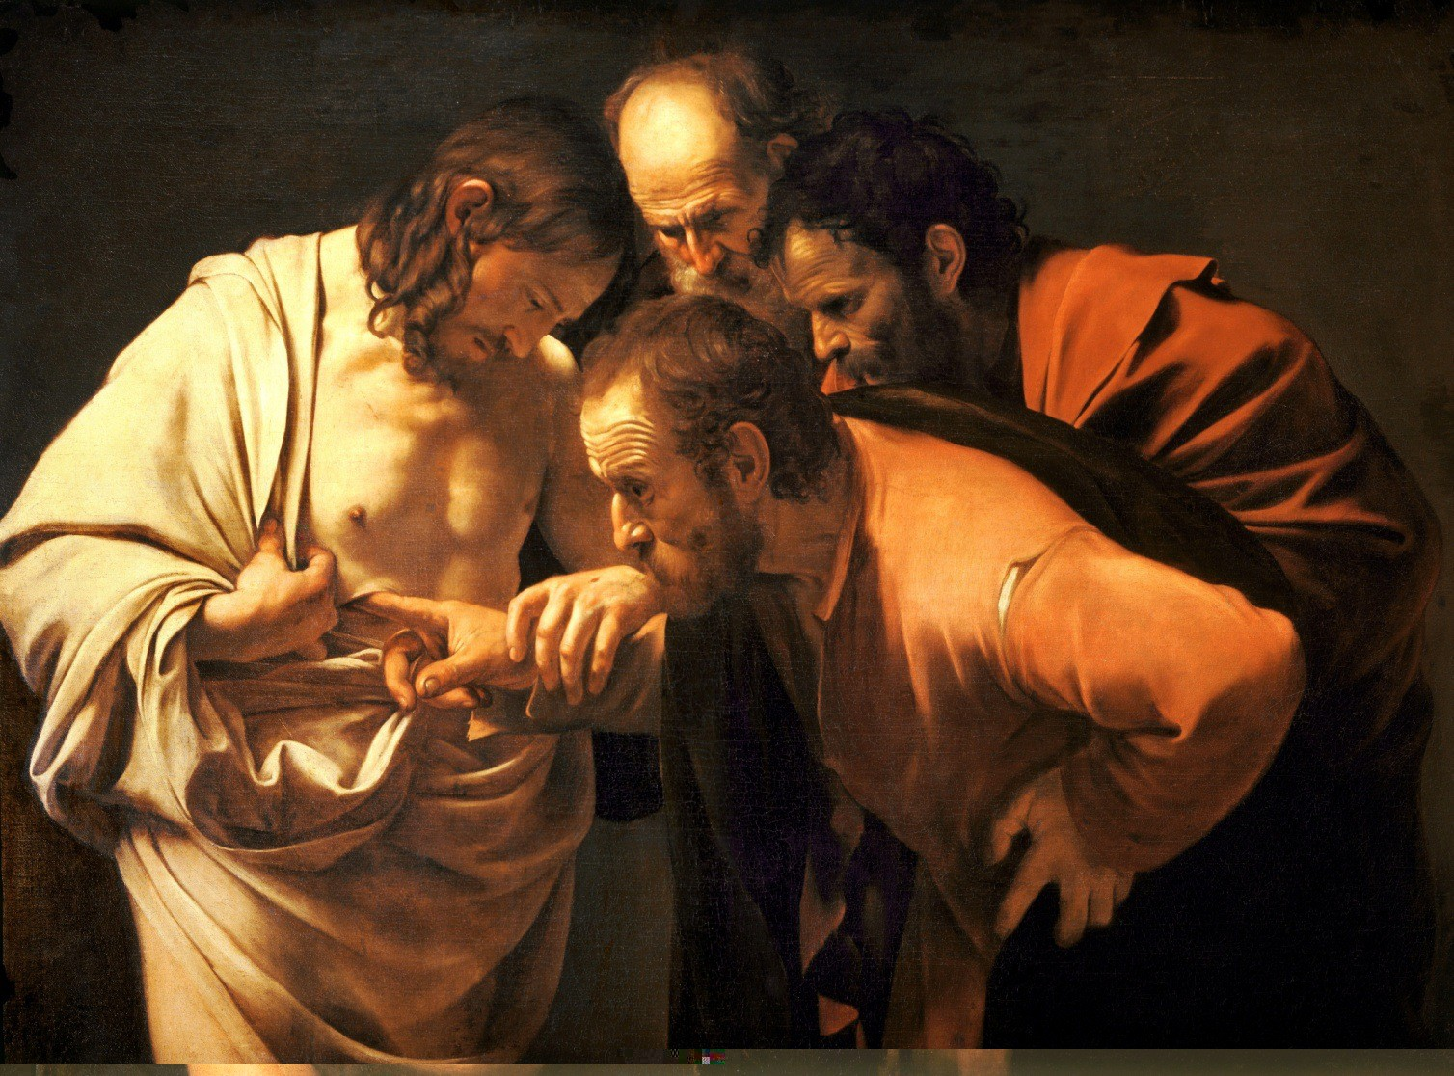

Saints Robert and William Catholic Parish

367 East 260th Street, Euclid, Ohio 44132 Phone: 216.731.1515 Fax: 216.731.0300

www.srweuclid.cc

Fr. John Betters Ext. 228 Fr. Scott Goodfellow Ext. 235 Renée Barber Ext. 262

fjb@srweuclid.cc frscott@srweuclid.cc rbarber@srweuclid.cc

The staff of Ss. Robert and William Parish has prepared these guidelines to assist your family in planning the Funeral Mass. We hope that by choosing the readings and music, you and your family might share more fully in the liturgy, and express your care and love for the deceased. Attached to this booklet is a liturgy planning form to plan the Funeral Liturgy. Please fill it out as best as possible and bring it with you to your meeting with the priest or pastoral associate. Be assured of the prayers of our parish during this time of sorrow.

General Information

Catholic Funeral
The Church confidently proclaims that Jesus, the Son of God, by his death and resurrection, has broken the chains of sin and death. The Order of Christian Funerals celebrates this in three groups of rites that correspond to the three ritual movements in the funeral of Christians. These three movements form one procession beginning with the Vigil (wake), followed by the Funeral Mass, and Rite of Committal at the cemetery. While this is the usual custom, options are available.

Cremation
In recent years, the restriction of cremation has been lifted. While the Church encourages cremation to follow the Funeral Liturgy, it realizes that financial constraints or other circumstances may result in the desire for cremation before the funeral services. Cremated remains are brought to the church and treated the same as if a body were present. The Church discourages the dividing or scattering of ashes.

Scheduling a Funeral
According to diocesan guidelines, funeral Masses can be held any day of the year with the exceptions of Sundays, Holy Days, or during the Sacred Triduum (Holy Thursday, Good Friday, Holy Saturday). In general, funerals are scheduled for 9:00AM and 10:30AM.

Mass Worship Booklets
Our parish is happy to provide the worship booklet for the funeral and asks only the information be given to as soon as possible to allow time for creating and printing. If you would like picture of your loved one included on the front of the booklet, email your picture to rbarber@srweuclid.cc or bring a picture with you when you come to meet with us and we will scan it for you. Please estimate the number of booklets that will be needed.

Ministers
Readers: We will provide readers from the parish to proclaim the readings and Universal Prayer. However, family or friends who want to participate in these liturgical roles may do so. Readers should be Catholics familiar with the Mass, and should have a good public speaking voice. We will provide you with copies of your chosen readings when you meet with the parish staff.
Gift Bearers: You may choose two or more people to bring the bread and wine forward during the Offertory.
Musicians and Servers: Our staff will contact our musicians and servers. If you choose to have other singers or musicians, please speak with the staff member with whom you are working. An additional stipend may be appropriate.

Stipends
All parishioners are entitled to our ministries without charge. We also would not exclude anyone who is not formally registered or hasn’t been able to contribute financially to the parish. Some people desire to make an offering to the church. Typically, a portion of the fees paid to the funeral director is used to cover the services of the music ministers (organist and cantor) and the priest (Total $350.00). Again, these are not required in order to receive a Christian burial.

Remarks of Remembrance (Eulogy) Guidelines
If a eulogy is given, it is most appropriate when given at the funeral home or cemetery. However, under exceptional circumstances where this is not possible, diocesan guidelines permit one person to offer a short eulogy at Mass following the Prayer after Communion. A good eulogy should only be 2-3 minutes (which amounts to one page, single-spaced, 12-point font). Please note that a eulogy is not a biography of the deceased, nor a long telling of many events and stories about the deceased. Rather, the eulogist shares one story to help those gathered remember the faith, hope, and love of the deceased on display. The eulogist should have some public speaking skills. He or she should keep all remarks appropriate for a Catholic Mass. Please give the priest celebrant a copy of the eulogy for feedback prior to the funeral.

Mass Offerings
Masses for the intention of the deceased can be requested through Ss. Robert and William or any parish church. The usual stipend is $10.00 per Mass. Due to a large volume of requests, we can only schedule two Masses per year for each household based on availability. Additional intentions may be distributed to other parishes, to the missions, or to retired priests.

Other Donations
If you wish to honor your loved one by making a donation to a special fund or ministry, our staff can assist you in that decision. We discourage individual purchases of memorial vessels and vestments since this often results in an overabundance of items for the parish.

Funeral Luncheons
We regret that, due to lack of available space, we are not able to offer funeral luncheons. However we do have an agreement with Mama Catena Ristorante, 711 Babbitt Rd. Please call them for arrangements (216.261.1168)

Universal Prayer (Prayer of the Faithful)
Please review the format of the Universal Prayer below. Let the priest know of any relatives, living or deceased, that you would like to add to these intentions:

For N. who in baptism was given the pledge of eternal life, that he/she may now be admitted to the company of the saints. We pray to the Lord.

For our brother/sister who ate the body of Christ, the bread of life, that he/she may be raised up on the last day. We pray to the Lord.

For our deceased relatives and friends, especially (deceased relatives may be listed here), and for all who have helped us, that they may have the reward of their goodness. We pray to the Lord.

For those who have fallen asleep in the hope of rising again, that they may see God face to face. We pray to the Lord.

For the family and friends of our brother/sister N., (any mourners may be listed here), that they may be consoled in their grief by the Lord, who wept at the death of his friend Lazarus. We pray to the Lord.

For all of us assembled here to worship in faith, that we may be gathered together again in God’s kingdom. We pray to the Lord.

Readings for the Liturgy of the Word

FIRST READING
The first reading is taken from the Old Testament, or from the Acts of the Apostles or Revelation during the Easter season. Please choose one of the following readings and mark your selection on the planning form. A short passage containing the main message of the reading has been provided.

1000 Job 19:1, 23-27a
“As for me, I know that my vindicator lives, and that he will at last stand forth upon the dust.”

1005 Proverbs 31:10-30
“When one finds a worthy wife, her value is far beyond pearls”

1010 Ecclesiastes 3:1-8, 14
“There is an appointed time for everything, and a time for every affair under the heavens.
A time to give birth and a time to die; a time to plant and a time to uproot the plant.”

1015 Wisdom 3:1-9 (Long Form) or 3:1-6, 9 (Short Form)
“The souls of the just are in the hands of God, and no torment shall touch them….

1020 Wisdom 4:7-15
“The righteous one, though he die early, shall be at rest.
For the age that is honorable comes not with the passing of time,
nor can it be measured in terms of years.”

1025 Sirach 3:2-5, 12-15
“The Lord sets a father in honor over his children…
My son, be steadfast in honoring your father; do not grieve him as long as he lives.”

1030 Isaiah 25:6a, 7-9
“The Lord God will wipe away the tears from all faces…
Indeed this is our God; we looked to him, and he has saved us!”

1035 Lamentations 3:22-26
“The favors of the Lord are not exhausted. his mercies are not spent;
They are renewed each morning – so great is his faithfulness.”

1040 [Easter Season] Acts 10:34-43 (Long Form) or 10:34-36, 42-43 (Short Form)
“To him all the prophets bear witness, that everyone who believes in him
will receive forgiveness of sins through his name.”

1045 [Easter Season] Revelation 14:13
“Blessed are the dead who die in the Lord from now on.
Let them find rest from their labors, for their works accompany them.”

1050 [Easter Season] Revelation 20:11 – 21:1
“Then I saw a new heaven and a new earth.
The former heaven and the former earth had passed away.”

1055 [Easter Season] Revelation 21:1-5a, 6b-7
“I saw the holy city, a new Jerusalem, coming down out of heaven from God.
I am the Alpha and the Omega, the beginning and the end.”

SECOND READING
The second reading is always taken from the New Testament. Please choose one of the following and indicate your selection on the planning form. A short passage containing the main message has been provided.

2000 Romans 5:5-11
“Hope does not disappoint because the love of God has been poured out into our hearts
through the Holy Spirit who has been given to us…
But God proves his love for us in that while we were still sinners, Christ died for us.”

2005 Romans 6:3-9 (Long Form) or 6:3-4, 8-9 (Short Form)
“Are you unaware that we who were baptized into Christ Jesus were baptized into his death?
As Christ was raised from the dead by the glory of the Father, we too might live in newness of life.”

2010 Romans 8:14-23
“You received a spirit of adoption, through which we say Abba ‘Father!’
We are children of God, and if children, then heirs.”

2015 Romans 8:31b-35, 37-39
“If God is for us, who can be against us?...What will separate us from the love of Christ?”

2020 Romans 14:7-9, 10c-12
“No one lives for oneself and no one dies for oneself.
For if we live, we live for the Lord, and if we die, we are the Lord’s;
so then, whether we live or die, we are the Lord’s.”

2025 1 Corinthians 15:51-57
“We shall not all fall asleep, but we will be changed, in an instant, in the blink of an eye…”

2030 2 Corinthians 4:14-18, 5:1
“We know that the One who raised the Lord Jesus will raise us also with Jesus.
For this momentary light affliction is producing for us an eternal weight of glory
beyond all comparison, as we look not to what is seen but to what is unseen…”

2035 2 Corinthians 5:1, 6-10
“We know that if our earthly dwelling, a tent, should be destroyed,
We have a building from God, a dwelling not made with hands, eternal in heaven.”

2040 Philippians 3:20-21
“Our citizenship is in heaven.”

2045 Philippians 4:4-9
“Have no anxiety at all, but in everything…make your requests known to God.
Then the peace of God that surpasses all understanding will guard your hearts and minds in Christ Jesus.”

2050 Thessalonians 4:13-18
“We do not want you to be unaware, brothers and sisters, about those who have fallen asleep,
so that you may not grieve like the rest who have no hope.”

2055 Timothy 4:6-8
“I have competed well; I have finished the race; I have kept the faith.”

2060 1 John 3:1-2
“See what love the Father has bestowed on us that we may be called children of God.”

GOSPEL
The Gospel is always proclaimed by the priest or deacon. Please choose one of the following Gospel readings and mark your selection on the planning form.

3000 Matthew 5:1-12a
“Blessed are the poor in spirit for theirs is the kingdom of heaven… Blessed are they who mourn, for they will be comforted.”

3005 Matthew 11:25-30
“Come to me, all you who labor and are burdened, and I will give you rest.”

3010 Matthew 25:31-46
“…whatever you did for one of these least brothers of mine, you did for me.”

3015 Mark 15:33-39, 16:1-6
“On entering the tomb they saw a young man sitting on the right side, clothed in a white robe,
and they were utterly amazed. He said to them, “Do not be amazed! You seek Jesus of Nazareth,
the crucified. He has been raised. He is not here.”

3020 Luke 7:11-17
“Young man, I tell you, arise.”

3025 Luke 12:35-40
“You also must be prepared, for at an hour you do not expect, the Son of Man will come.”

3030 Luke 23:33, 39-43
“Jesus, remember me when you come into your kingdom…”
“…Amen I say to you, today you will be with me in Paradise.”

3035 Luke 24:13-16, 28-35
“Was it not necessary that the Messiah should suffer these things and enter into his glory…
“ Stay with us, Lord, for evening draws near…”Were not our hearts burning within?”

3040 John 6:37-40
“For this is the will of my Father, that everyone who sees the Son and believes in him
may have eternal life, and I shall raise them on the last day.”

3045 John 6:51-58
“I am the living bread that came down from heaven: whoever eats this bread will live forever…”

3050 John 11:17-27
“I am the resurrection and the life; whoever believes in me, even if he dies, will live.”

3055 John 11:32-45
“Mary said, ‘Lord, if you had been here, my brother would not have died’…and Jesus wept.”

3060 John 12:23-28 (Long Form) or 12:23-26 (Short Form)
“unless a grain of wheat falls to the ground and dies, it remains just a grain of wheat;
but if it dies, it produces much fruit.”

3065 John 14:1-6
“Do not let your hearts be troubled. You have faith in God; have faith also in me.
In my Father’s house there are many dwelling places.”

Music Selections

RESPONSORIAL PSALM
The musician and cantor lead the assembly in singing the response. Please choose one of the following Psalm responses and mark your selection on the planning form.

Psalm 23 “The Lord is my shepherd, there is nothing I shall want.”
– or –
“Though I walk in the valley of darkness, I fear no evil, for you are with me.”

Psalm 25 “To you, O Lord, I lift my soul.”

Psalm 27 “The Lord is my light and my salvation.”

Psalm 103 “The Lord is kind and merciful

Psalm 116 “I will walk in the presence of the Lord in the land of the living.”

HYMNS
Please choose a hymn under each heading. Reflection Hymn is optional. The hymns listed under each heading are suggestions; they may be moved elsewhere. Numbers correspond to Journey Songs hymnal used by our parish. Only sacred (religious) music may be used at the Funeral Mass. It is never appropriate to use secular music.

Opening Hymns
Be Not Afraid 673
Here I Am, Lord 818
I Heard the Voice of Jesus Say 692
I Know That My Redeemer Lives 556
Joyful, Joyful We Adore You 575
Lord of All Hopefulness 647
On Eagle’s Wings 671
There’s A Wideness in God’s Mercy 712

Offertory Hymns
Be Still My Soul 547
Be Thou My Vision 646
Come to the Water 626
How Great Thou Art 614
Open My Eyes, Lord 659
Precious Lord, Take My Hand 548
Prayer of St. Francis 702
Remember Your Love 533
The King of Love (Irish) 690
You Are Mine
You Are Near 687

Communion Hymns
Behold the Lamb 785
Blest Are They
Center of My Life 665
Eye Has Not Seen
I Am the Bread of Life
I Received the Living God 786
Jesus, Remember Me
One Bread, One Body 793
Taste and See
The Supper of the Lord 774
Unless a Grain of Wheat 725

Reflection Hymns (Optional)
Amazing Grace 680
Ave Maria
How Great Thou Art 614
Panis Angelicus
Prayer of St. Francis 702

Closing Hymns
City of God 813
For All the Saints 504
Holy God, We Praise Thy Name 566
Jerusalem, My Happy Home 758
Lead Me, Lord 733
We Will Rise Again 681
Sing With All the Saints in Glory 759

Funeral Mass Planning Sheet

Funeral of: Date: Time:

Presider: ○ Body or ○ Cremains (Ashes)

Booklets Needed (i.e. Guest Count):

Liturgy of the Word

1st Reading:

2nd Reading:

Gospel: (Read by Priest)

Presentation of the Offertory Gifts (2-4 people):

Hymns

Opening Hymn:

Responsorial Psalm:

Offertory Hymn:

Communion Hymn:

(Optional) Reflection Song:

Closing Hymn:

What are a few things you will remember most about the character of the deceased?

Other Notes or Questions:

